**Experiment No.: 1 Date:19/12/2022**

**Aim:**

Write a Python program to read a file line by line and store it into a list

**CO 5:**

Create files and form regular expressions for effective search operations on strings and files

**Procedure:**

# Program to read file content and store it into a list using readlines().

open_file = open('Data.txt')

File_Lines = open_file.readlines()

# Without using strip

print("\nFile content with newline character:")

print(File_Lines)

# By using strip

print("\nFile content after removing newline character:")

File_Lines = [X.strip() for X in File_Lines]

print(File_Lines)

# print([X.strip() for X in File_Lines])

open_file.close()

**Output Screenshot:**

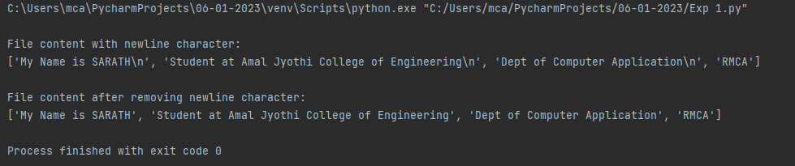

**Result:**

The program was executed and the result was successfully obtained. Thus CO5 was obtained.

**Experiment No.: 2 Date:06/01/2023**

**Aim:**

Write a Python program to copy odd lines of one file to other.

**CO 5:**

Create files and form regular expressions for effective search operations on strings and files

**Procedure:**

# Program to copy odd lines of one file to another.

# Opening files for reading and writing data.

input_file = open('Data.txt')

output_file = open('writedata.txt','w')

# Copying /reading contents from read_file to copy_data

copy_data = input_file.readlines()

print("\nActual File Content is:")

print(copy_data, "\n")

for i in range(0, len(copy_data)):

if i % 2 == 0:

output_file.write(copy_data[i])

else:

pass

# Closing file after writing

output_file.close()

# Opening write file in read mode and printing values

output_file = open('Writedata.txt','r')

print("Odd lines Are:")

print(output_file.read())

# Closing files

input_file.close()

output_file.close()

**Output Screenshot:**

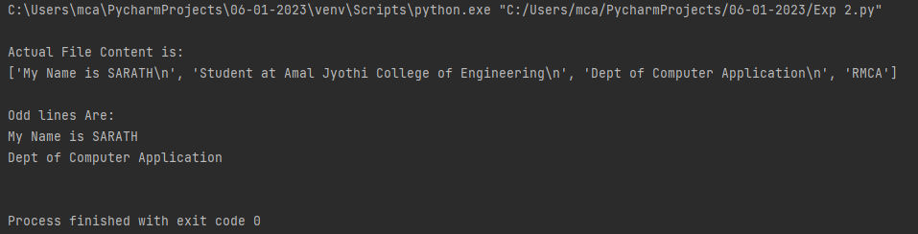

**Result:**

The program was executed and the result was successfully obtained. Thus CO5 was obtained.

**Experiment No.: 3 Date:06/01/2023**

**Aim:**

Write a Python program to read each row from a given csv file and

print a list of strings.

**CO 5:**

Create files and form regular expressions for effective search operations on strings and files

**Procedure:**

# Program to read each row from a given csv file and print a list of strings.

import csv

# Open the csv file

with open('names.csv','r') as file:

# Create a csv reader

reader = csv.reader(file)

# Iterate over the rows of the CSV file

for row in reader:

# Print the rows as a list of strings

print(row)

**Output Screenshot:**

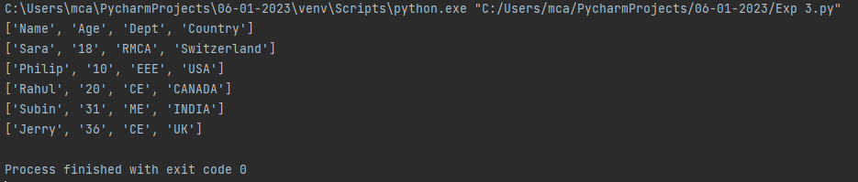

**Result:**

The program was executed and the result was successfully obtained. Thus CO5 was obtained.

**Experiment No.: 4 Date:06/01/2023**

**Aim:**

Write a Python program to read specific columns of a given CSV file

and print the content of the columns.

**CO 5:**

Create files and form regular expressions for effective search operations on strings and files

**Procedure:**

# Program to read specific columns of a given CSV file and print the content of the columns.

import csv

# specify the column indices that you want to read

# e.g. column 0 is the first column, column 1 is the second column, etc.

columns_to_read = [0,2]

# Open the CSV file and read the contents

with open('names.csv','r') as f:

clmn_reader = csv.reader(f)

# Iterate over the rows of the CSV file

for row in clmn_reader:

# Print the rows as a list of strings

print([row[i] for i in columns_to_read])

**Output Screenshot:**

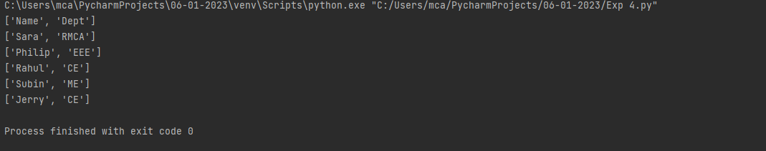

**Result:**

The program was executed and the result was successfully obtained. Thus CO5 was obtained.

**Experiment No.: 5 Date:06/01/2023**

**Aim:**

Write a Python program to write a Python dictionary to a csv file.

After writing the CSV file read the CSV file and display the content.

**CO 5:**

Create files and form regular expressions for effective search operations on strings and files

**Procedure:**

# Write a Python program to write a Python dictionary to a csv file.

# After writing the CSV file read the CSV file and display the content.

import csv

# Data to be inserted

data = [{'Name': 'Keerthi', 'Age': 21, 'Country': 'United States'},

{'Name': 'Amal Thomson', 'Age': 26, 'Country': 'Canada'},

{'Name': 'Sara', 'Age': 20, 'Country': 'Switzerland'},

{'Name': 'Rahul', 'Age': 23, 'Country': 'USA'},

{'Name': 'Sreerag', 'Age': 24, 'Country': 'Neitherland'},

{'Name': 'Sarath', 'Age': 23, 'Country': 'Ireland'},

{'Name': 'John', 'Age': 20, 'Country': 'India'},

{'Name': 'Subin', 'Age': 24, 'Country': 'New Zealand'},

{'Name': 'Kavya', 'Age': 25, 'Country': 'Austarlia'}]

# Write to CSV file

with open('people.csv', 'w') as csvfile:

headernames = ['Name', 'Age', 'Country']

csvwriter = csv.DictWriter(csvfile, fieldnames=headernames)

csvwriter.writeheader()

for row in data:

csvwriter.writerow(row)

# Read from CSV file and print contents

with open('people.csv', 'r') as csvfile:

reader = csv.DictReader(csvfile)

for row in reader:

print(row)

**Output Screenshot:**

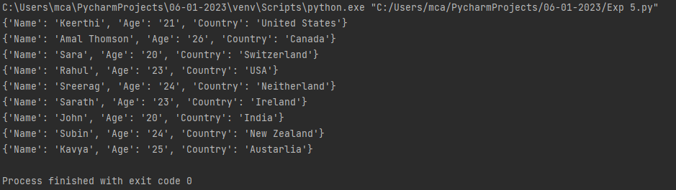

**Result:**

The program was executed and the result was successfully obtained. Thus CO5 was obtained.